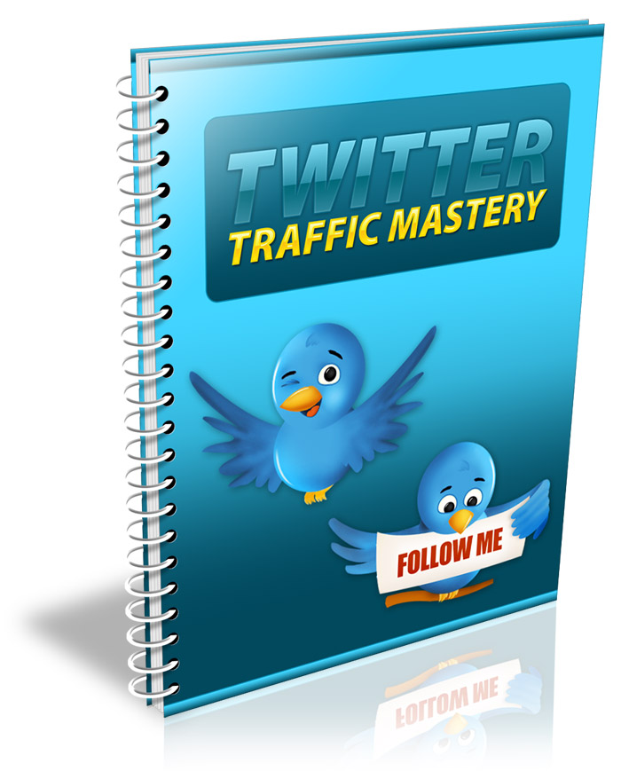
Table of Contents
Introduction 3
Getting Started 4
Build a List 6
Twitter Traffic 9

Get Your Free Bonuses Here . . .
To say “Thanks” for taking the time to read this guide, I’ve put together a special page full of free bonuses for you. These are all great resources, and can all help your business in some way.
Have a look at the following page, and get the bonuses that can help you with your business . . .
www.GetYourFreeBonuses.com

Introduction
Twitter is an incredibly powerful social website. With millions of users who visit the site daily, it can’t be overlooked as part of a comprehensive online marketing plan.
Twitter is great for busy marketers, because the format requires short, succinct posts that grab attention but don’t take a lot of time to create.
These days, people prefer to get their information as quickly and easily as possible. Twitter makes it easy to reach these users efficiently, without overloading them with information and making them tune you out.
In this report, you’re going to learn how to use the massive power of Twitter to grow your business. I will show you exactly how to harness their massive database of users for your own personal gain, and how to squeeze every last drop out of your followers!
So let’s get started!

Getting Started
The first thing you need to do is sign up for a Twitter account if you don’t already have one. This is incredibly easy. Just visit http://www.twitter.com and click the “Sign up now” button.
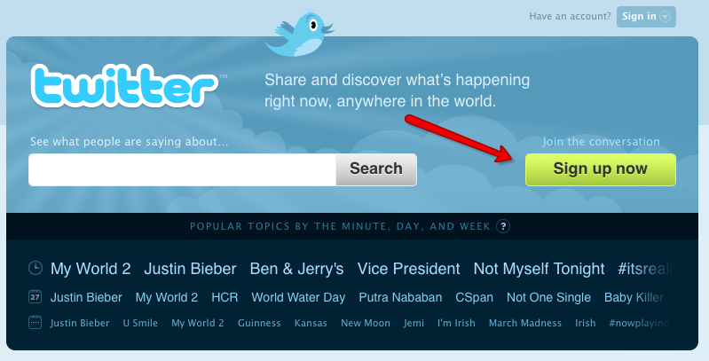
After you sign up, you’ll need to modify your profile. People won’t take you seriously if you don’t fill out your profile completely. Spammers tend to set up a Twitter account just to spam people, and they don’t fill out their profile fully. By completing yours, you will set yourself apart and give yourself a little boost in credibility.
First of all, be sure to add your URL to your bio. Every user who visits your profile will see it!
You might want to make this URL lead to a squeeze page so you can capture users onto your opt-in email list. This will let you build a resource outside of Twitter’s rules that you can market to any way you see fit.
You will also want to add keywords that are relevant to your industry. If you are marketing in the golf niche, you will want to put acne-related keywords here. This will help users find you if they want to locate people who are also into golf. You can enter your keywords separated by commas.
You may also want to have an original background image created for your profile. This might contain a picture of you, a picture of your product, and contact information. You might also want to include your URL on the image.
Don’t forget to upload a photo of yourself or an avatar. This will help users notice and remember you, and it will also help you stand out from other users.

Build a List
Building a list is one of the most vital things you can do with Twitter. Any time you are marketing on a web property you don’t own, you’re running the risk that your account could be deleted or the site could change its terms and nullify your campaign.
When you build a list, you will be able to market to that list for many years to come. Best of all, you won’t have to worry about breaking Twitter’s terms, even if they change the terms later. You can market to your own list any legal way you want!
You will need an autoresponder account in order to manage your list effectively. A good autoresponder account is well worth the money, and you will be able to email your list quickly and easily.
The two top providers are:
http://www.GetResponse.com
http://www.Aweber.com
Both services are excellent, but I find Aweber to be slightly better in terms of deliverability.
Once you sign up for your autoresponder account, you will need to add the code to your squeeze page. This form will allow users to enter their name and email address to join your mailing list.
If you’ve never set up a squeeze page before, you can get some help at:
http://www.bigbangtemplates.com
http://www.pluginsqueezepage.com
A squeeze page is similar to a sales page, but it’s shorter and simpler. You need to make sure your squeeze page tells people why they should sign up to your list.
You might give away an incentive like a free report, a video tutorial, or a free educational course that is delivered daily to their email. You can set your autoresponder up to deliver the freebie automatically after they sign up.
Just make sure the incentive you offer is relevant to your niche. A 10 page report on saving money off the purchase of a car might be interesting, but it’s not going to appeal to golf traffic as much as a 10 page report on improving your golf swing!
If you want to test different squeeze pages for effectiveness, you can do so for free using Google’s Website optimizer:
http://www.google.com/websiteoptimizer
This tool is free to use, and it will let you split test different versions of your squeeze page to find out which one is most effective.
Once your squeeze page has been set up and is ready to receive traffic, it’s time to start sending traffic to it!

Twitter Traffic
Perhaps the easiest way to get traffic from Twitter is to set up a system that will automatically send messages to your new followers and direct them to your squeeze page.
You can set up an account at a site like:
http://www.socialoomph.com/register
This site will allow you to automatically send a welcome message to all of your Twitter followers. You can welcome them to your list of followers and invite them to sign up for your newsletter.
They automate everything for you!
First you will need to register for a free trial account. Once you have done this, you will need to click on “Add a New Scheduled Status Update”.
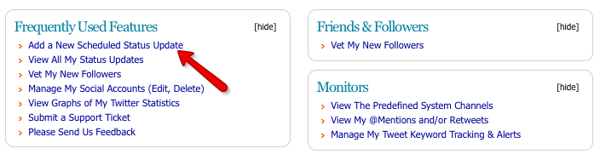
You will need to be sure to let Social Oomph sync with your Twitter account. You will need to give the system permission to access your Twitter account.
NOTE: You can also manage multiple Twitter accounts from one Social Oomph account!
Next, you need to enter your automated greeting:
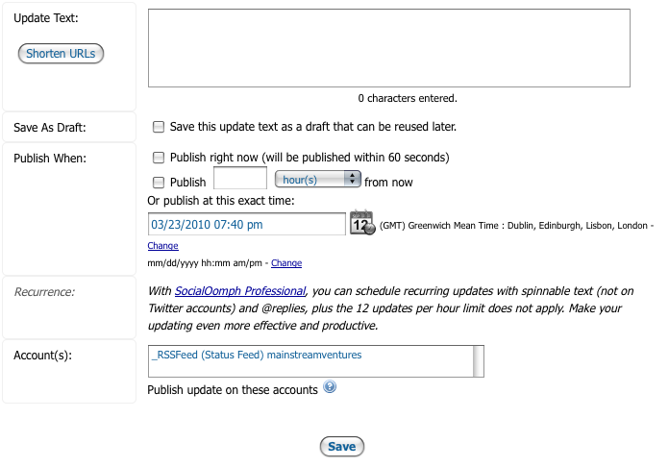
These messages can be posted to your Twitter feed whenever you choose.
Then you need to set up the direct message that will be sent to your followers when they follow you:
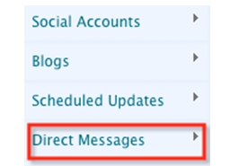
Choose “Schedule New DM”. Then you wil be able to enter an automated message that will thank each user for joining your network and invite them to visit your squeeze page.
This will allow you to build a targeted list of followers that you can use for many years to promote products to, and it will be an invaluable resource that will be well worth the time and effort it takes to build it.
Good luck!

